Overview: Trella Health created a series of email templates for your organization to use to help guide your outreach. You can use the following emails as one-off emails or in a cadence. A cadence is a series of outreaches over multiple days or weeks, and typically includes different types of outreach such as emails, phone calls, and LinkedIn connections. Many business development teams use cadences to improve the effectiveness of their outreach and increase the likelihood of engaging with their referral targets.

In cadences, it is best to highlight the most important metric or information for your recipient in your first email, since your first email typically will have the highest open rates. After reading through the email templates below, investigate with your team to discover which of the following is the strongest metric for your organization and place that at the beginning of your cadence. The following emails should highlight other compelling data-points or key attributes of your agency that benefit your prospect. The goal of a multi-touch cadence is to show the value of your agency piece by piece, as not to overwhelm your prospect.

*Note: The following emails have the same opening/closing paragraph. If using the emails as a cadence, remember to edit.

Hospice Email One: Physician Under-Utilizing Hospice

Subject: Your Utilization Performance Compared to Your Peers

Hello {Referral Partner Name Here},

I hope you and your team are doing well and staying safe. We understand our healthcare system’s landscape has changed dramatically and rapidly due to the COVID-19 pandemic. We’re reaching out to show our support and offer assistance in providing care for patients in this challenging environment.

Utilizing hospice as an additional resource during these challenging times can reduce readmissions as well as ER and observational visits for high risk patients. Our data shows you have a lower utilization rate in comparison with your peers in your state. Referring terminally ill patients to hospice care can help keep those who are most vulnerable out of acute settings as much as possible, lowering their chances of being exposed to COVID-19.

Example screenshot- insert one that is most applicable for the referral partner you’re contacting
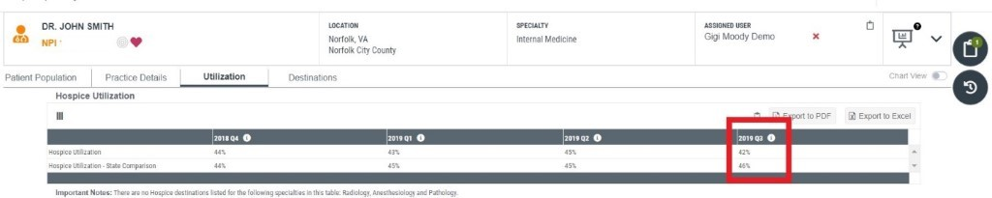

Are you available to meet via [insert the tools your agency uses such as Zoom/video conference/a phone call] to discuss how we can partner to identify hospice eligible patients? It is [insert your agency’s name] goal to ensure your patients receive the highest level of care from the comfort of their own home.

Stay safe,
(my first name)

Hospice Email Two: Hospitalization Rates

Subject: Limit Hospital Visits During Covid-19

Hello {Referral Partner Name Here},

I hope you and your team are doing well and staying safe. We understand our healthcare system’s landscape has changed dramatically and rapidly due to the COVID-19 pandemic. We’re reaching out to show our support and offer assistance in providing care for patients in this challenging environment.

When treated by our agency, fewer patients go to the hospital within 30 days across the major diagnostic category {example} compared to our peers. Our track record would make us a great partner for your facility during these troubling times to ensure the most vulnerable populations are less likely to seek care at a facility and risk exposure.

Example screenshot- insert one that is most applicable for the referral partner you’re contacting
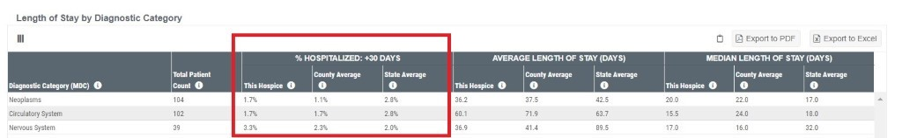
Are you available to meet via [insert the tools your agency uses such as Zoom/video conference/a phone call] to discuss how we can partner? It is [insert your agency’s name] goal to ensure your patients receive the highest level of care from the comfort of their own home.

Stay safe,
(my first name)

***Disclaimer: You must turn off chart view in Marketscape to be able to see the table in the example above.

Hospice Email Three: Intensity of Care- Last Seven Days or Last Three Days

Subject: Lower Chance of Your Patients’ Exposure to COVID-19 with AGENCY NAME

Hello {Referral Partner Name Here},

I hope you and your team are doing well and staying safe. We understand our healthcare system’s landscape has changed dramatically and rapidly due to the COVID-19 pandemic. We’re reaching out to show our support and offer assistance in providing care for patients in this challenging environment.

Our hospice provides a higher level and intensity of care during [the last seven days/last three days] of life than our peers.

Example screenshot- insert one that is most applicable for the referral partner you’re contacting
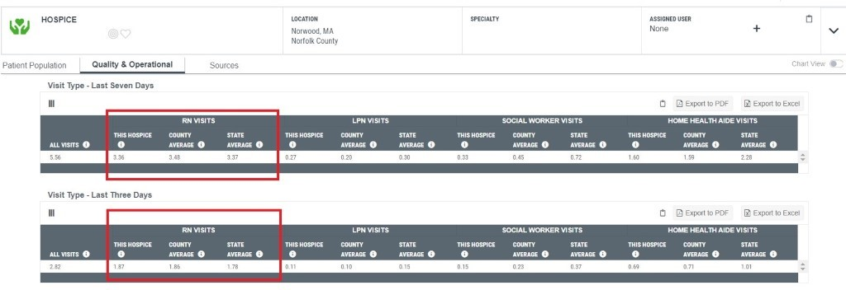
Are you available to meet via [insert the tools your agency uses such as Zoom/video conference/a phone call] to discuss how we can partner? It is [insert your agency’s name] goal to ensure your patients receive the highest level of care and compassion from the comfort of their own home.

Stay safe,
(my first name)

Hospice Email Four: ALOS Email

Subject: Your ALOS Compared to Your Peers

Hello {Referral Partner Name Here},

I hope you and your team are doing well and staying safe. We understand our healthcare system’s landscape has changed dramatically and rapidly due to the COVID-19 pandemic. We’re reaching out to show our support and offer assistance in providing care for patients in this challenging environment.

Utilizing hospice as an additional resource during these challenging times can reduce readmissions, ER and observational visits, and exposure. Our data shows that your patients have a lower average length of stay compared to similar physicians. Your hospice ALOS is X, compared to PHYSICIAN NAME’s ALOS of Y. By identifying hospice-appropriate patients earlier, we can work together to keep the most vulnerable populations out of acute settings to lower their chance of being exposed to COVID-19.

Example screenshot- insert one that is most applicable for the referral partner you’re contacting
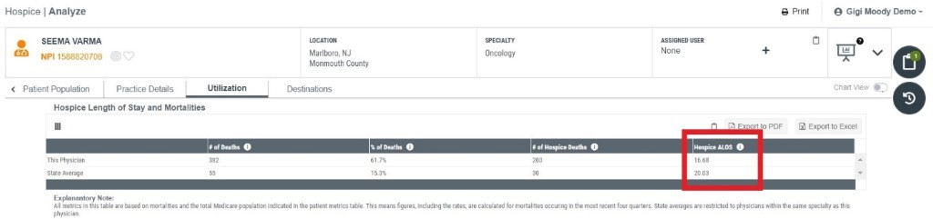

Are you available to meet via [insert the tools your agency uses such as Zoom/video conference/a phone call] to discuss how we can partner? It is [insert your agency’s name] goal to ensure your patients receive the highest level of care from the comfort of their own home.

Stay safe,
(my first name)

