Overview: Trella Health created a series of email templates for your organization to use to help guide your outreach. You can use the following emails as one-off emails or in a cadence. A cadence is a series of outreaches over multiple days or weeks, and typically includes different types of outreach such as emails, phone calls, and LinkedIn connections. Many business development teams use cadences to improve the effectiveness of their outreach and increase the likelihood of engaging with their referral targets.

In cadences, it is best to highlight the most important metric or information for your recipient in your first email, since your first email typically will have the highest open rates. After reading through the email templates below, investigate with your team to discover which of the following is the strongest metric for your organization and place that at the beginning of your cadence. The following emails should highlight other compelling data-points or key attributes of your agency that benefit your prospect. The goal of a multi-touch cadence is to show the value of your agency piece by piece, as not to overwhelm your prospect.

*Note: The following emails have the same opening/closing paragraph. If using the emails as a cadence, remember to edit.

Home Health Email One: Home Health Utilization

Subject: Your Utilization Performance Compared to Your Peers

Hello {Referral Partner Name Here},

I hope you and your team are doing well and staying safe. We understand our healthcare system’s landscape has changed dramatically and rapidly due to the COVID-19 pandemic. We’re reaching out to show our support and offer assistance in providing care for patients in this challenging environment.

Utilizing home health as an additional resource during these challenging times can reduce hospitalizations, readmissions, as well as ER and observational visits for high risk patients. Our data shows you have a lower utilization rate in comparison with your peers. By increasing your home health utilization, we can work together to keep vulnerable populations out of acute settings, lowering their chances of being exposed to COVID-19.

Example screenshot- insert one that is most applicable for the referral partner you’re contacting
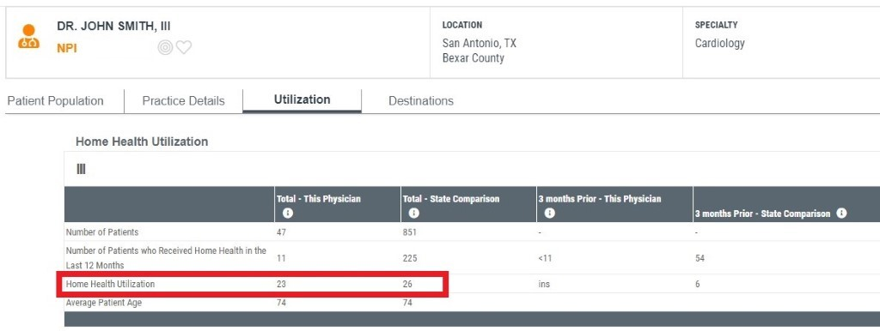

Are you available to meet via [insert the tools your agency uses such as Zoom/video conference/a phone call] to discuss how we can partner to help discover home health appropriate patients? It is [insert your agency’s name] goal to ensure your patients receive the highest level of care from the comfort of their own home.

Stay safe,
(my first name)

Home Health Email Two: Hospitalization Rates

Subject: Limit Hospital Visits During COVID-19

Hello {Referral Partner Name Here},

I hope you and your team are doing well and staying safe. We understand our healthcare system’s landscape has changed dramatically and rapidly due to the COVID-19 pandemic. We’re reaching out to show our support and offer assistance in providing care for patients in this challenging environment.

Our home health agency is performing better than our peers when it comes to hospitalization rates within [30/90] days from start of care, which I understand is a major focus of your practice. Our track record would make us a great partner for you during these troubling times as we work to ensure high risk populations have a lower chance of requiring care at an acute facility where they could risk exposure to the virus.

Example screenshot- insert one that is most applicable for the referral partner you’re contacting
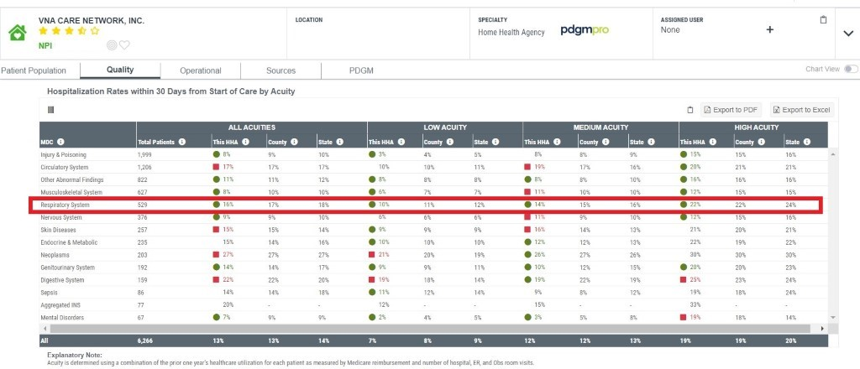
Are you available to meet via [insert the tools your agency uses such as Zoom/video conference/a phone call] to discuss how we can partner to help discover home health appropriate patients? It is [insert your agency’s name] goal to ensure your patients receive the highest level of care from the comfort of their own home.

Stay safe,
(my first name)

Home Health Email Three: Readmission Rate

Subject: Lower Chance of Your Patients’ Exposure to COVID-19 with AGENCY NAME

Hello {Referral Partner Name Here},

I hope you and your team are doing well and staying safe. We understand our healthcare system’s landscape has changed dramatically and rapidly due to the COVID-19 pandemic. We’re reaching out to show our support and offer assistance in providing care for patients in this challenging environment.

When treated by our agency, fewer patients return to a hospital during a home health episode across the major diagnostic category {example} compared to our peers. Our track record would make us a great partner for your facility during these troubling times to ensure the most vulnerable populations have a lower chance of returning to a facility and risk exposure.

Example screenshot- insert one that is most applicable for the referral partner you’re contacting

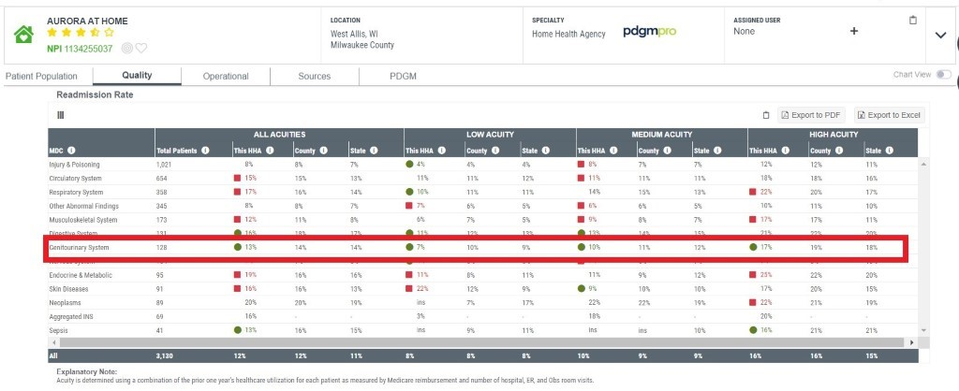

Are you available to meet via [insert the tools your agency uses such as Zoom/video conference/a phone call] to discuss how we can partner a to help discover home health appropriate patients? It is [insert your agency’s name] goal to ensure your patients receive the highest level of care from the comfort of their own home.

Stay safe,
(my first name)

Home Health Email Four: Performance Across Acuities

Subject: AGENCY NAME Performance with DIAGNOSTIC CODE Patients

Hello {Referral Partner Name Here},

I hope you and your team are doing well and staying safe. We understand our healthcare system’s landscape has changed dramatically and rapidly due to the COVID-19 pandemic. We’re reaching out to show our support and offer assistance in providing care for patients in this challenging environment.

Our team is experienced at caring for {diagnostic category} patients. That’s why we outperform our peers when it comes to {metric}. Our track record would make us a great partner for your facility during these troubling times as facilities are trying to maximize their capacities for COVID-19. To ensure your high acuity patients get the care they need, (AGENCY NAME) is ready to help care for your patients. We wish to assist you in any way we can during this pandemic.

Example screenshot- insert one that is most applicable for the referral partner you’re contacting

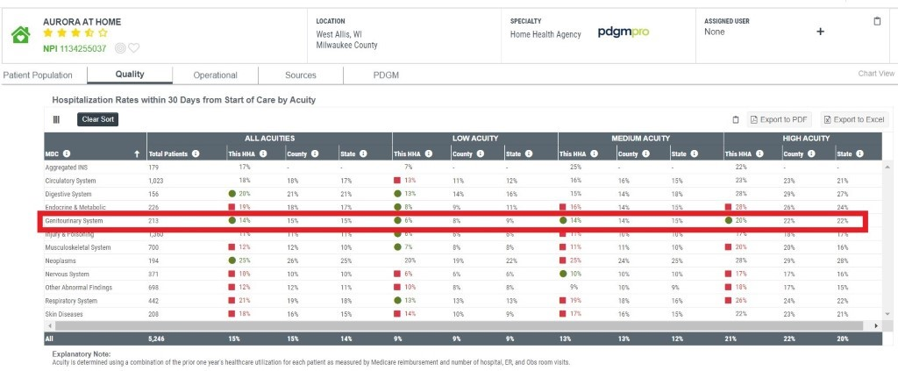

Are you available to meet via [insert the tools your agency uses such as Zoom/video conference/a phone call] to discuss how we can partner a to help discover home health appropriate patients? It is [insert your agency’s name] goal to ensure your patients receive the highest level of care from the comfort of their own home.

Stay safe,
(my first name)

